**DAILY ONLINE ACTIVITIES SUMMARY**

|  |  |  |  |  |  |  |  |  |
| --- | --- | --- | --- | --- | --- | --- | --- | --- |
| **Date:** | **29/05/2020** | | | | | **Name:** | **Prashant Rama Bhat Kodlekere** | |
| **Sem & Sec** | **4th sem (B sec)** | | | | | **USN:** | **4AL18CS060** | |
| **Online Test Summary** | | | | | | | | |
| **Subject** | | **OPERATING SYSTEM** | | | | | | |
| **Max. Marks** | | **30** | | **Score** | | | **29** | |
| **Certification Course Summary** | | | | | | | | |
| **Course** | **Python3 for biginners in 2020** | | | | | | | |
| **Certificate Provider** | | | **Udemy** | | **Duration** | | | Section 5 and 6 |
| **Coding Challenges** | | | | | | | | |
| **Problem Statement:** Write a Java program to Find size of the largest ‘+’ formed by all ones in a binary matrix  Top of Form  Bottom of Form | | | | | | | | |
| **Status:Completed** | | | | | | | | |
| **Uploaded the report in Github** | | | | | **YES** | | | |
| **If yes Repository name** | | | | | **https://github.com/prashantkodlekere/codingactivity** | | | |
| **Uploaded the report in slack** | | | | | **YES** | | | |

Online Test Details:

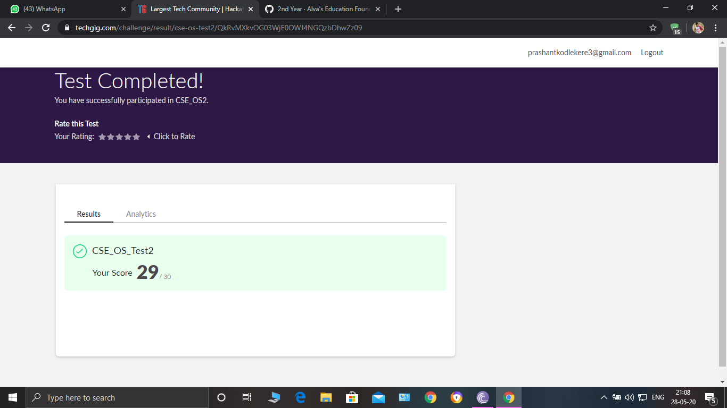

OPERATING SYSTEM Internals was conducted. A total of 30 questionS were Multiple Choice Questions.

The above snapshot is the result sheet which was mailed to us by the Techgig team.

Certification Course Details:

Course name:Python3 for biginners in 2020(5th and 6th section)

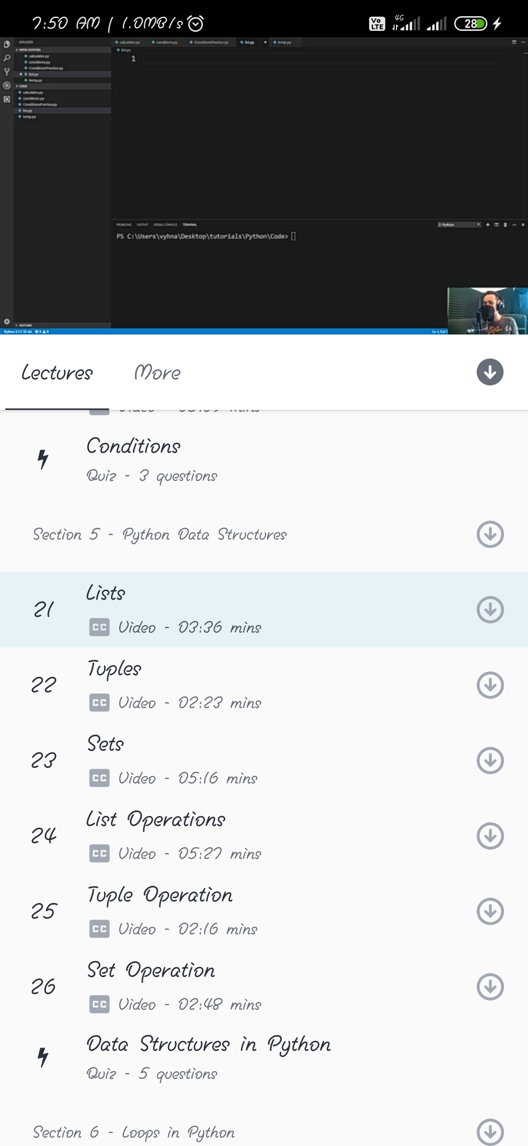

In section 5, I have learnt about lists,tuples,sets,list operations,and set operations and I have taken a small quiz.

In section 6,I have learnt about different loops like for loop,range,while loops,and about break and continue and dictionaries.then I took a small quiz.

Coding Challenges Details:

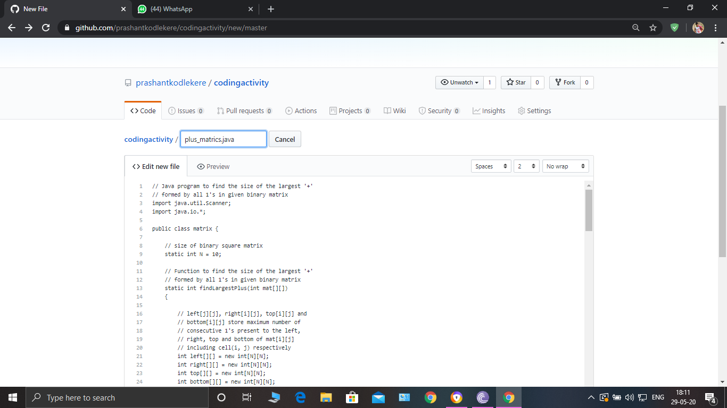

**The question I took to code is:**

Write a Java program to Find size of the largest ‘+’ formed by all ones in a binary matrix.

Code: The above snapshot is the code which I have uploaded in my Github repository.